PRACTICAL: 4.3

**AIM:** Implement RIP routing protocol in WAN.

# THEORY:

* RIP stands for Routing Information Protocol.
* RIP is a simple vector routing protocol with many existing implementations in the field. In a vector routing protocol, the routers exchange network reachability information with their nearest neighbors.
* A vector routing protocol floods reach ability information throughout all routers participating in the protocol, so that every router has a routing table containing the complete set of destinations known to the participating routers.

# TOPOLOGY 1:

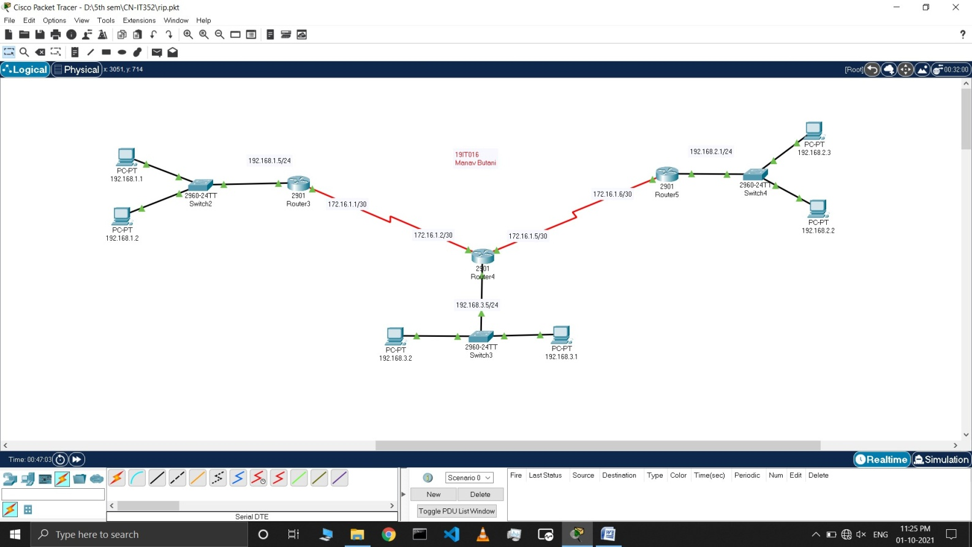

**TOPOLOGY 2:**

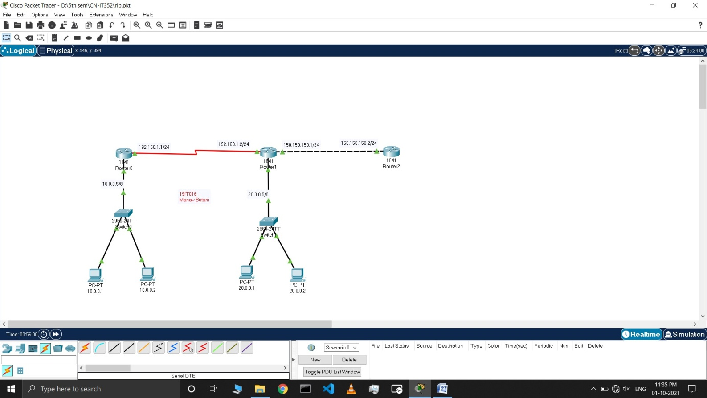

# Commands for Topology 1:

* First make the topology as shown in the above figure.

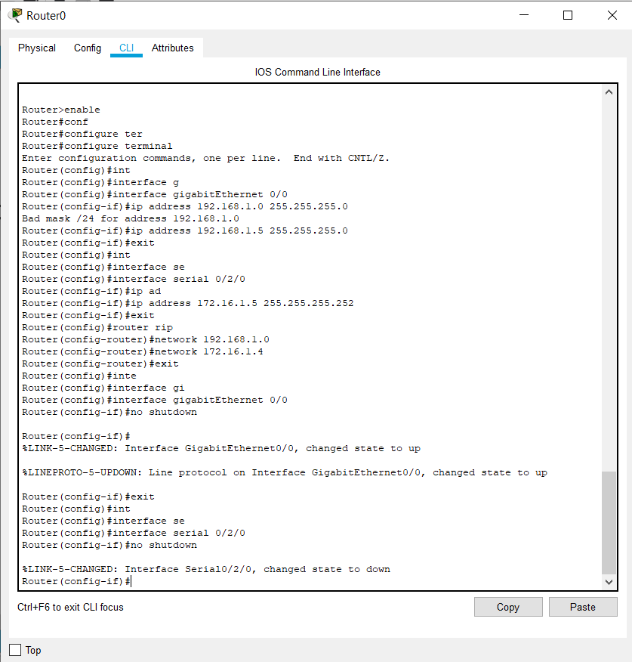

* Now open cli of router 0 and assign all IP address as shown in topology using cmd like
  + enable
  + configure terminal
  + interface <cable type> <cable port>
  + no shutdown
* Now add in RIP table using **router rip** cmd and add each network with their network address using cmd **network <network address>** for all the network connected to router 0.

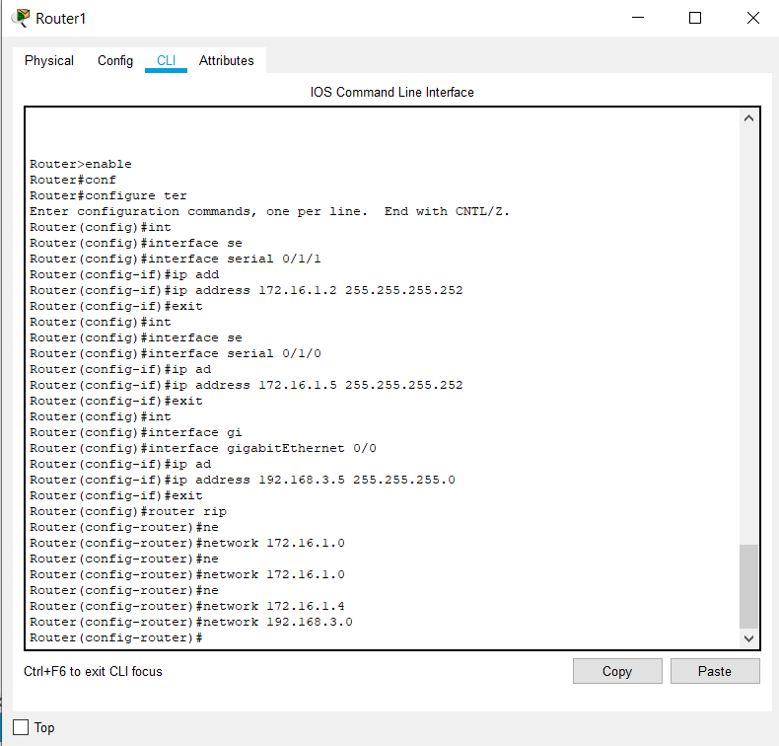

* Now open cli of router1 and assign all IP address as shown in topology using cmd like
  + enable
  + configure terminal
  + interface <cable type> <cable port>
  + no shutdown
* Now add in RIP table using **router rip** cmd and add each network with their network address using cmd **network <network address>** for all the network connected to router 1.

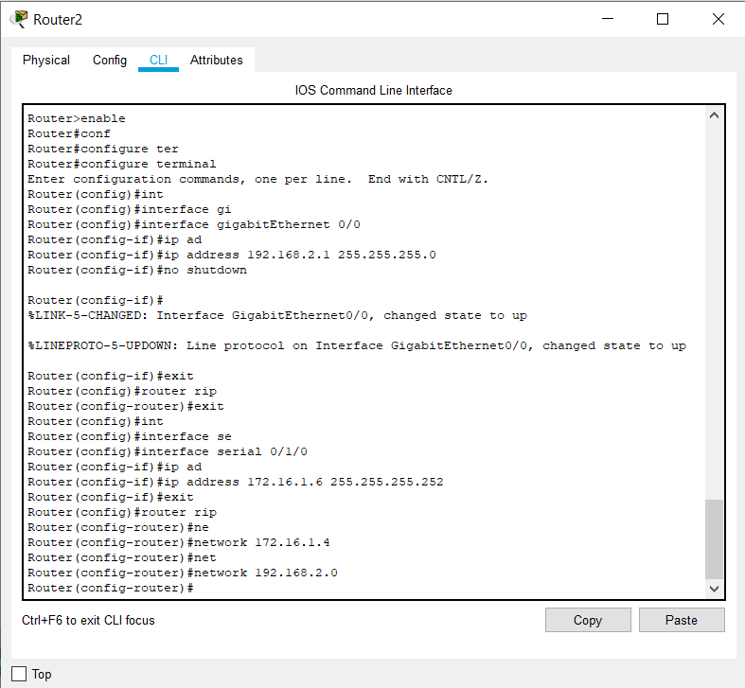

* Now open cli of router 2 and assign all IP address as shown in topology using cmd like
  + enable
  + configure terminal
  + interface <cable type> <cable port>
  + no shutdown
* Now add in RIP table using **router rip** cmd and add each network with their network address using cmd **network <network address>** for all the network connected to router 2.

# OUTPUTS:

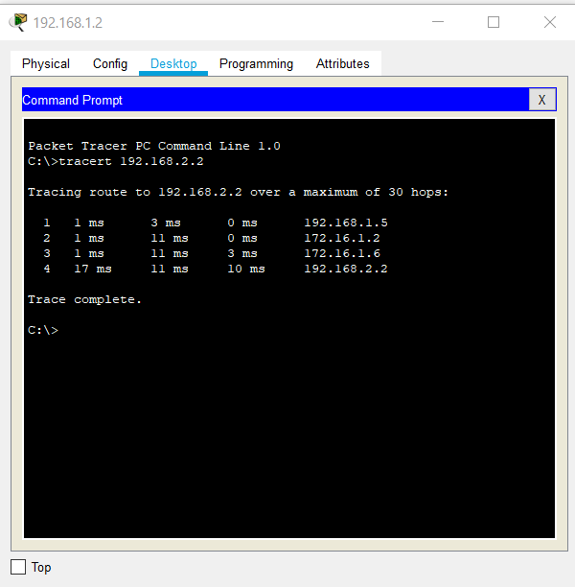

* Here we can see that we are able to transmit our packet to desired target in topology1.

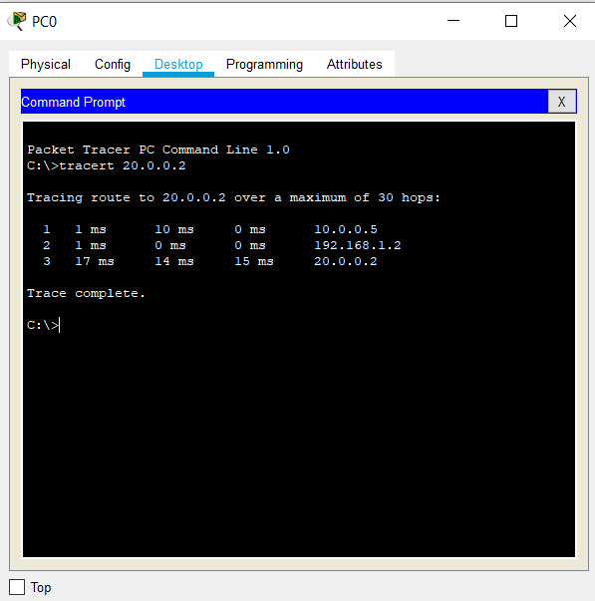

* Here we can see that we are able to transmit our packet to desired target in topology 2.

# LATEST APPLICATIONS:

* RIP is used to configure the hosts as part of a RIP network. This type of routing requires little maintenance and also automatically reconfigures routing tables when your network changes or network communication stops.
* It is used to find the best path between the source and the destination with the help of hop count as a routing metric.

# LEARNING OUTCOME:

* How to configure RIP routing in a network with classful and classless both class type.